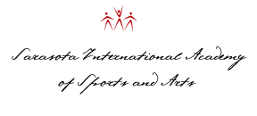

Good morning (name),

My name is Joe Pickett, President of the Sarasota International Academy of Sports & Arts in Sarasota, Florida. It is our privilege to have as our academy partner, Steve Stennes & Nancy Knight, who have created an amazing digital visual arts training academy for middle and high school students. We are in the process of making all of our announcements to the art industry for this new academy partnership.

Steve & Nancy contacted you as we are looking for U.S. and international companies and individuals who want to send students to the SIASA Academy in Sarasota, Florida, so they may further their education, Arts & Sports career. SIASA Academies offers a residential academy in Sarasota, Florida, for 6th thru 12th grade and the post graduate year - focused on individual sports performance training for all athletes as well as a world class art programs for painting, photography, video production, animation, dance, game design, acting, voice and music. These individual programs are designed to enhance each student’s skills to not only be competitive within their sport or art but to also better equip them to reach their full academic potential. We offer fulltime, semester & camp program for digital visual art students around the world. I have outlined a few of our programs below.

SIASA Academies Prep Academy:

Our fully accredited College Preparatory Academy provides a full-time, residential athletic training program for student athletes. The Academy is a coed, boarding and day school for middle school thru 12th grade and for post graduate students as well. The Academy offers flexible prep school courses, allowing student athletes to train and compete at the highest levels so as to ultimately prepare for the ideal collegiate academic/athletic opportunity. The Preparatory Academy completes the I-20 form to allow international students to receive an F1 Student Visa to attend.

SIASA Academies Arts & Sports Programs:

Individual academy training with the most advanced training methods and instruction available. SIASA Academies offers sports programs in Golf, Soccer, Beach Volleyball, Indoor Volleyball, Baseball, Softball, Bowling, Archery, Basketball, Sailing and Equestrian. While SIASA Arts programs, provide internationally acclaimed instruction in Music, Dance, Voice, Acting, Painting, Drawing, Gaming, Visual Arts, Ballet & Photography. With new programs in Archery, Sailing and Rowing beginning in the fall of 2014.



Post Graduate Programs:

Colleges fully recognize the value of students enrolling after a Post Grad experience. With a growing demand and need for such a specialized offering. Many graduating seniors today are not ready physically, technically and/or competitively to excel at their desired level of college sports. Likewise, some student athletes are searching for a year where they can live independently and better prepare for the rigors of college life. And there may be academic reasons why taking an extra year between high school and college is the best course of action (i.e., SAT/ACT issues, ESL or TOEFL issues, GPA problems, the chance to take college credits in advance, etc.).

SIASA Academy Camp Program:

SIASA offers coed, summer boarding and day camps for the novice to elite level. All SIASA camps parallel the boarding Academy program, and focus on technical, tactical, physical and mental aspects of the art or sport for the optimal performance edge.

So, if you know someone who would benefit from the SIASA Academy Training experience, we want to hear from you. Please contact Steve, Nancy or myself for additional details on how you can work with SIASA Academies to help students reach their full potential in art & academics, while you receive a healthy commission.

Have a fantastic day and we hope to hear from you soon!

Joe Pickett

President

Sarasota International Academy of Sports & Arts

4301 32nd St. W. Bradenton, FL 34205

PHONE: 941-224-7344

EMAIL: [Info@SarasotaIASA.com](mailto:Info@SarasotaIASA.com)

Website: <http://www.SarasotaIASA.com>

Steve Stennes

President & CCO

[Stennes Studios Inc.](http://www.stennesstudios.com/)  
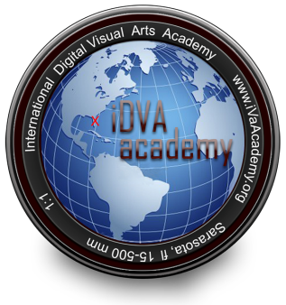[iDVA academy LLC.](iDVAacademy.org) (International Digital Visual Arts Academy)

[www.StennesStudios.com](www.stennesstudios.com)  
941-544-5704 cell  
  
Nancy Knight  
President

[Immersed Imagery LLC](http://www.immersedimagery.com/).